Caretakers Southwest News Letter November 2018

New Website
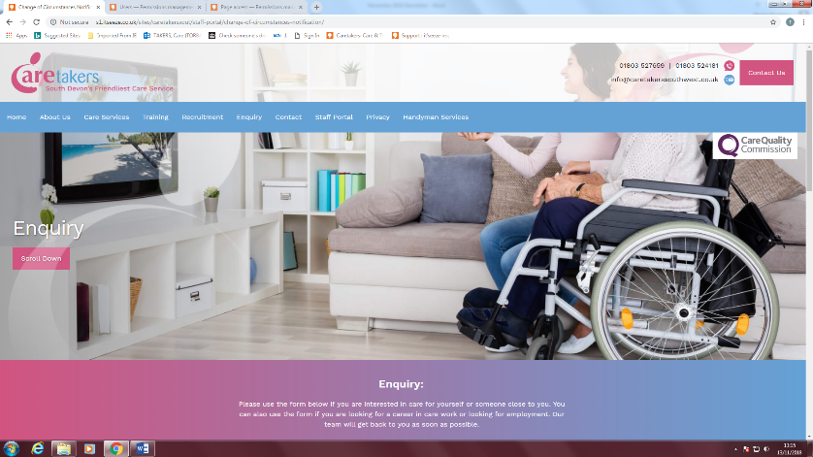
We are proud to announce this month that our new website us up and running! We have also added a new staff portal so you can access new relevant information such as training videos, useful telephone numbers, policies, an anonymous reporting tool, payslip portal, etc. We will also be migrating all key safe codes to the website soon for data protection purposes under the new GDPR legislation.
For this to work we have hidden all these goodies behind a password that all staff have access to. The website address is:
http://www.caretakerssouthwest.co.uk
For access, your login id is:
“first name”.”last name” (don’t forget the full stop in the middle)
Your password is your National Insurance Number.
If you are unable to log in, please call matt and he will sort it for you. A mini training course will also be available soon to help you navigate the site.
If you have any suggestions for what else you would like to see on the website, please let us know.
Completing visit reports in the care plan.
We have recently had a spate of concerns from the care trust where allegations of staff not completing their tasks have been made. I would like to confirm that all of you have been completing your tasks but due to colleagues not filling in their visit reports or not supplying enough information these allegations are being made, this in turn means we do not have any evidence to support you when these allegations are made.

Please make sure to fill in the care plan before you leave each client’s address with exact information on what has or hasn’t been completed, and the reasons why. For your extra protection we have also added a change of circumstance form to the staff portal on the website that can be completed and sent at any time, which will let the office know immediately, if you have come across any issues that have caused you trouble in completing your duties, or any concerns you wish to raise.
We bring this to you attention as we have been notified that the Care Trust will be performing spot checks over the next few months.
Please also remember that all timesheets must be signed.

Training
Thank you to everyone who attended the week of training at the end of October, we managed to catch up on quite a few of the mandatory updates.
However, many people failed to turn up. This in turn has cost us a large sum of money for no shows. Therefore, failure to attend without a valid reason and notice, will now incur a £20.00 charge per person, per course.

We will next be focusing of the Mandatory Care Certificate course for those who are eligible. Tracy will contact you soon if you qualify for these courses.
We will also have a report writing course available in the 2019, watch this space!
Out of Hours Calling
Most of you are now using the on call phone appropriately, this is just a reminder so we can get this issue sorted:
Please ensure that you only phone the on call number FOR EMERGENCIES ONLY, not for checking rotas or payroll queries. These call must be made to the office Mon – Fri 9am – 5pm. Calls are now being logged on evenings and weekends. Further annoyances may cause a change in policy to come in line with the rest of the industry.
Attached Paperwork
Falls Prevention & Post Falls Management

