Caretakers Southwest News Letter December 2018
Winter Vehicle Checks & Making Time
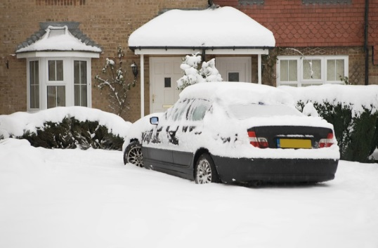
It’s that time of year again so we thought we’d give out a little advice due to the upcoming changes in the weather.
Please make sure all of your vehicles have been checked for oil water and anti-freeze. You may also require a thicker mixture of screen wash to prevent freezing your windscreen over.
Please also remember to allow for extra time in the mornings as you may have to defrost your windscreens.
Please also make sure to wrap up warm as this season is due to be extremely bitter. Above all else, please make sure to keep yourself safe! Please also make sure to keep your phone batteries charged in case you need help. You may also wish to create a winter vehicle survival pack containing items such as a torch, water and energy bars, blankets, etc.
Can you please also ensure that when you receive your rotas that you have all updated key safe codes and addresses as this weekend saw an unsatisfactory level of calls asking for addresses at the last minute, especially as we were out in the community dealing with clients ourselves.
Last year we did outstandingly in maintaining visits to our clients over the winter. No other company came close. Here’s hoping we can do the same this year!
This Months KLOE’s
This month’s subject is “Is the service responsive to people’s needs?” For you to fill in your form, you can log in to the staff portal on the website, hover over the KLOEs and a new tab called this month’s survey will appear. Just click on it, fill in the boxes and submit your opinion. We will then publish the results on the website for you to see. Thank you in advance.
Absence Monitoring
In light of another provider’s front page news all local domiciliary services are being watched very closely for missed visits, medication errors, etc. Please make sure that you attend all visits, keep absences to a minimum and report all errors, risks, suspicions or allegations to the office. Please remember that we are duty bound to do this under Duty of Candour legislation and CQC Regulations 12 and 18.

Xmas Schedules
If you receive any schedules from our clients when on your visits can you please get them in to the office ASAP, as we require them to create the Xmas rotas. You may have to remind the clients if you find them blank.
In case we don’t’ speak to you before, we wish you a Merry Xmas and glad tidings for the new year!

