Caretakers Southwest News Letter September 2018
Dear Colleague,
Summer Holidays Sickness
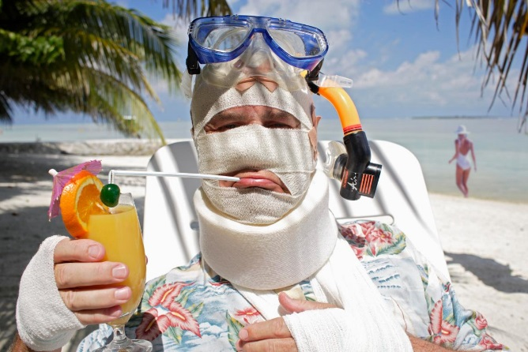
You may already have received your official letter in regards to our sickness levels over the 6 week school holidays and the danger posed to our clients. If you have not received your letter, please let the office know ASAP as due to the levels we have had to change our working practices and therefore our sickness policy has changed.

Conduct in front of our Clients
We have had complaint from some clients that staff are replying to text messages in from of them. Please be aware that this will not be tolerated and is seen as a disciplinary offence. Further infringements will lead to action on this.

Training
Now that the summer holidays are over, we will be beginning a new blitz on training over the next few months. We will aim to give as much notice as possible but please ensure you will be available on Tuesdays for the upcoming courses. If you are unable to attend, can you let the office know as soon as possible as we have a four day week booked 17th to 20th September to be as flexible as possible for you.

We also have made a training room available for all staff to attend where we will be undergoing practical training for moving and Handling. Please stand by for dates.
Out of Hours Calling
Please ensure that you only phone the on call number FOR EMERGENCIES ONLY, not for checking rotas or payroll queries. These call must be made to the office Mon – Fri 9am – 5pm. Calls are now being logged on evenings and weekends. Further annoyances may cause a change in policy to come in line with the rest of the industry.
This months Attached paperwork
Update – Repositioning a patient using slide sheets
Dysphagia consistency changes IDDSI Poster

