SAFE USE OF BED RAILS

Caretakers Southwest Ltd

Scope
- Policy Statement
- The Policy
- Assessment
- Potential Risks
- Ensuring the Correct use of Bed Rails
- Examples of Bed Rail Entrapment
- Risk of fall when using Bed Rails
- Key points to be considered before the use of Bed Rails
- Alternatives to using rigid bedrails
- Related Policies
- Related Guidance
- Training Statement

Policy Statement

The use of bed rails is from time to time, unavoidable for the health, safety and wellbeing of our service users. Where the service user has capacity, a full discussion takes place between the service user and the health professional e.g. Occupational therapist, consent is obtained before bed rails are put into place.
If the service user has bedrails in place before the commencement of the service advice is taken from an Occupational Therapist. The Bedrails are the responsibility of the service user or their family in this situation.
Where a service user lacks capacity, bed rails are considered a restriction or restraint as defined by the Mental Capacity Act 2005. A standard authorisation request must be made to the appropriate supervising body. Only after the authorisation is granted can bed rails be fitted and used.
This organisation follows guidelines prepared by the Department of Health, “Positive and Proactive Care: reducing the need for restrictive interventions” issued in April 2014.

Rigid bed rails can be classified into two basic types:
- Integral types that are incorporated into the bed design and supplied with it or are offered as an optional accessory by the bed manufacturer, to be fitted later.
- third party types that are not specific to any particular model of bed. They may be intended to fit a wide range of domestic, divan or metal framed beds from different suppliers

The Policy

Assessment
The assessment, must initially be carried out by a health professional who retains accountability. such as a Occupational Therapist. Consideration will be given as to whether bed rails are the appropriate means of managing that risk. For example, if the individual is likely to try to climb over the rails due to confusion, then other control measures (such as extra-low beds and/or sensor alarms) will be more appropriate.
Bed rails are not intended to:
- Limit freedom of movement
- Restrain people
- Be used as grab handles

Every effort is made to involve the service user or their family in the decision-making process with the health professional and to explain why and how bed rails are used. Families sometimes expect bed rails to be used out of concern for the safety of their relatives, not realising the potential risks, and that their use may not be the best approach. Where bed rails are fitted, staff are made aware of the risks and how to ensure the service user’s safety. Information on whether bed rails are used is included in the service user’s care plan.

Potential Risks
The following potential risks from the use of bed rails will be considered:
- Falling out of the end of the bed or over the top of the bed rail
- Entrapment between the bed rails and the mattress
- Entrapment between the bed rails and the head and foot of the bed
- Individual attempting to climb over the rails
- Failure of the bed rails
- Climbing over the footboard
- Violently shaking and dislodging rails
- Violent contact with parts of the bed rail
Consideration is given to the individual’s strength; individuals who are weak may be unable to move their own position, and therefore be at risk of asphyxiation if their head or neck became draped over the rail

Ensuring the Correct use of Bed Rails
[Note: BS EN 60601-2-52:2010 came into force for all new equipment manufactured or supplied from 1 April 2013.] Bed rail dimensions in BS EN 50637 issued in 2017 when assessing risk and ensuring correct fitting:
When using bed rails we work with other professionals such as the O.T or District Nurses and the bed rail supplier to ensure the compatibility of the service user, bed, mattress, bed rail and any associated equipment. Both bed rails should be used to eliminate gaps between the bed and other furniture or wall and to help keep the mattress in position.
Some key points must be considered relating to the potential for entrapment:
- Underneath the rail
- Between the end of the rail and the headboard or footboard
- Between the rail and the side of the mattress
- Between the bed-rail bars

Examples of Bed Rail Entrapment

Entrapment underneath the rail
The service user can become trapped between the bottom of the rail and the mattress if the gap beneath the rail is too large. This could be due to:
- Incompatibility of bed rail and bed
- Using an airflow mattress in conjunction with a thin-base mattress
- Using easily compressible base mattresses or a mattress which is too small for the bed
- Using an airflow mattress, which may be more compressible at the edges, in conjunction with thinner or easily compressible base mattresses, could allow access to the gap under the rail
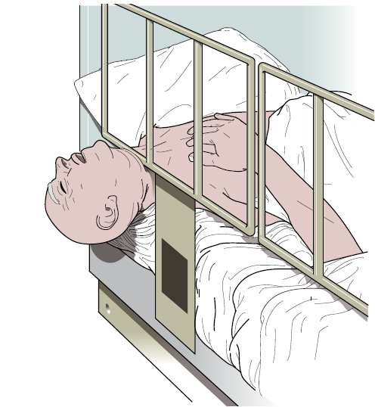
Figure 1 Entrapment under the rail can lead to asphyxiation
British Standard BS EN 60601-2-52:2010 states that the gap from any accessible opening between the bottom of the side rail and the mattress platform should be no more than 60 mm. When assessing this gap, it should be taken into consideration whether mattresses are thin, easily compressible at the edge and whether the individual’s dimensions increase the risk of slipping underneath the rails. Mattresses should always fit snugly, with no significant gap, between both bed rails.

Entrapment between the end of the rail and the headboard or footboard
If the rails are not secured in a safe position Service users can become trapped between the end of the bed rail and the headboard or footboard

Figure 2 Entrapment between the end of the bed rail and the headboard
British Standard BS EN 60601-2-52:2010 states that:
- The gap between the end of the bed rail and headboard should be no more than 60 mm
- The gap between the footboard and end of the bed rail should either be 60 mm or less, or greater than 318 mm, to prevent asphyxiation
- Likewise, where two-section split rails are used, the gap between the two sections should be 60 mm or less, or greater than 318 mm

Entrapment between the bed rail and the side of the mattress
A poorly fitting mattress can lead to entrapment in the space between the side of the mattress and the rail. This can be caused by:
- Poorly fitting bed rail system and/or insecure fittings that allow the bed rail to move away from the side of the bed
- Bed rails only being used on one side of the bed, allowing the mattress to move away from it

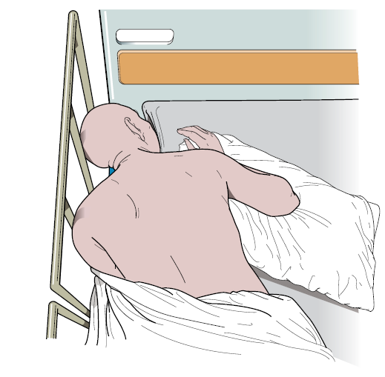

Figure 3 Entrapment between the bed rail and the side of the mattress
Replacement mattresses that are narrower than the original mattress, or smaller speciality mattresses used on top of existing mattresses, may result in an excessive gap between the mattress and the bed rail. Poorly maintained bed rails may be too flexible, may deform under force or have too much play in their fixings, resulting in a gap between the mattress edge and rail.
The mattress should fit snugly between both rails so it does not allow entrapment of the occupant’s head or body. This gap must be checked, taking into account the service user using the bed rails.
Bed-rail bumpers or gap fillers can be used in conjunction with bed rails. When used(in conjunction with a correctly fitted bed rail), accessories should be robust, so they cannot accidentally be displaced or easily damaged. They conform to the British Standards and checks should be made with the bedrail supplier before use.

Bed Bumpers
- As there is a risk of the individual trapping their head, body or limbs between the rails, specifically designed padded accessories such as Bed Bumpers must be properly applied. Where unavailable, this must be documented and bed rails must not be used
- It must be remembered that some padded accessories are not air permeable and may present a suffocation risk if the individual was to become entrapped
- Bed rail bumpers, padded accessories or enveloping covers are primarily used to prevent impact injuries, however, bumpers that can move or compress may themselves introduce entrapment risk
- Bed bumpers must be cleaned daily using detergent and water, preferably with disposable cloths or wipes; wipe all outer surfaces and dry thoroughly
- Bed bumpers must be checked for signs of damage at each clean; any sign of damage must be reported and the bumper removed
- The inspections must be documented and records kept
When bed rails are in use they should be inspected for defects and security each time they are raised.
To enable staff to check for safety before use and during their use they receive training from the Occupational Therapist who then signs off their competency to carry out the necessary checks. As for level 3 specialised training.

Key points to be considered before and during the use of Bed Rails
- Are bed rails only provided where they are the most appropriate solution to prevent falls?
- Are staff trained in the risks and safe use of bed rails?
- Are rails and any accessories compatible with the bed, mattress and occupant?
- Does the mattress fit snugly between the rails?
- Are rails correctly fitted on both sides of the bed, secure, regularly inspected and maintained?
- Are checks completed to ensure that gaps that could cause entrapment of neck, head, and chest are eliminated?
- Are all relevant records reviewed and updated in particular relation to the Mental Capacity Act 2005, the DOLs authorisation must be regularly reviewed?

Bed rails should be maintained in accordance with the manufacturer’s recommendations in the instructions for use. Examples of common types of damage include:
- Adjusters, clamps and fixings can wear, work loose, crack, deform or be missing completely, giving rise to unwanted free play which can increase important gaps
- Material fatigue can also occur. Bed occupants who rattle the bed rails can exacerbate this tendency
- Telescopic components can become loose or jammed, discouraging correct adjustment
- Plastic components can degrade due to age, exposure to light and some cleaning chemicals
- Poor transport and storage can also cause damage to components
- Duvets, blankets, sheets and valances may need to be removed to check these areas properly
- Bedrails should be cleaned weekly or more often if required.
Bed rail assemblies should be traceable, for example by using the manufacturers serial number, the Unique Device Identification number (when available) or labelling with an in-house number. This will assist in ensuring that every device is regularly inspected and maintained in a satisfactory condition.
Traceability also allows devices to be suitably identified should a safety issue arise, such as a manufacturer recall due to a fault.
Records should be kept of inspections, repairs and maintenance completed on bed rails.
Manufacturers should be able to advise on the expected working life of their products.

Risk of falls when using Bed Rails
Falls can occur if a service user climbs or rolls over the top of the rails. The height of a bed rail above the level of the compressed mattress can prevent an inadvertent fall from a bed. BS EN 60601-2-52:2010 quotes a minimum height of 220 mm, measured vertically from the top edge of an uncompressed mattress to the top of the bed rail.
Replacing a mattress with one significantly thicker than that intended by the bed manufacturer, placing one mattress on top of another, or using mattress overlays or airflow mattresses, may reduce the effectiveness of the bed rails because the relative height of the rail is reduced. This could increase the risk of a person involuntarily rolling or falling over the top of the bed rail.
Checks are carried out with the suppliers that the bed rails are high enough to take into account any increase in mattress thickness or additional overlay.
BS EN 60601-2-52:2010 states that, where a ‘speciality’ or ‘mattress overlay’ is used and the side rail does not meet the minimum height of 220 mm above the mattress, a risk assessment should be carried out to assure equivalent safety.

Alternatives to rigid bed rails
Alternatives to bed rails will be considered, such as:
- Netting’ or mesh bed sides
- Ultra ‘low height’ beds that minimise the risk of fall injuries
- Positional wedges to reduce movement across the bed alarm systems to alert carers that a person has moved from their normal position or wants to get out of bed
- Fall mats that can be placed beside the bed to reduce the severity of the impact if the bed occupant does fall
Each of these options may act to introduce different hazards even as they reduce the risk of bed fall injury or the risk from bed rails and will be managed appropriately.
Further Guidance
Our Bedrail Suppliers are Torbay Care Trust

Related Policies

Accidents, Incidents and Emergencies Reporting ( RIDDOR)
Adult Safeguarding
Health and Safety
Restraint

Related Guidance

- Safer use of bedrails https://www.gov.uk/guidance/bed-rails-management-and-safe-use March 2020
- HSE webpage on safe use of bed rails: www.hse.gov.uk/healthservices/bed-rails.htm
- BS EN 60601-2-52:2010 Particular requirements for basic safety and essential performance of medical beds British Standards Institution http://www.hse.gov.uk/foi/internalops/sims/pub_serv/07-12-06/appendix-3.pdf
- Bedrails;management and safe use https://www.gov.uk/government/publications/bed-rails-management-and-safe-use
- MHRA Draft Guidance September 2019 https://assets.publishing.service.gov.uk/government/uploads/system/uploads/attachment_data/file/820830/Safe_Use_of_Bed_Rails_guidance_-_draft.pdf

Training Statement

All staff, during induction are made aware of the organisations policies and procedures, all of which are used for training updates. All policies and procedures are reviewed and amended where necessary and staff are made aware of any changes. Observations are undertaken to check skills and competencies. Various methods of training are used including one to one, on-line, workbook, group meetings, individual supervisions and external courses are sourced as required.

