Caretakers Southwest Ltd News Letter April 2019

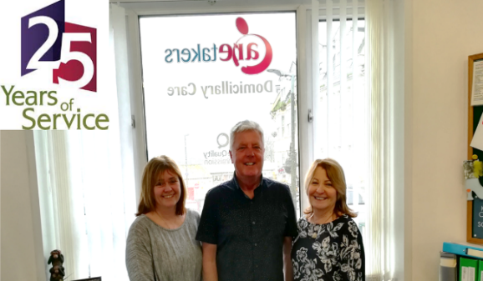
25 Years of Service!
We are proud to announce that this year we are celebrating our 25th Anniversary of providing care services to Torbay.
We never thought all those years ago when we set up the business from our living room, how many lives we could affect in a positive way. Here’s to the next 25 years!
Coffee Mornings
We will be holding coffee mornings every first Monday of the month from 10am to 12pm. This is where both our clients and our staff are welcome to pop in and meet Gail and the team for a chat and a free drink, and to ask any questions you may have. We will be holding this down the road from our office at 8A Hyde Road in Paignton. If you require instructions on how to get there, please call into the office and ask. Our next date is 6th May.

Website Training
Our new website is now up and running where it now includes a new staff portal as well as tools for clients to ask any questions they may have, this can also be used for complaints and compliments. For staff, we will be holding training sessions, but for any of our clients, please pop in during our coffee mornings and we’ll guide you on how to use the website. Our website address is: www.caretakerssouthwest.co.uk
Holidays
Just a quick reminder for staff, the holiday season is now approaching. Please remember to book your holiday dates with us prior to making your reservation, to avoid disappointment. We will try to accommodate as much as possible, but please remember that we have a duty to support our clients with continuity of regular staff.
New Job Roles
In line with our continual development, we now have three roles available. We are looking for a Client Welfare Champion for each area (1 in Torquay and 1 in Paignton). The person will receive extra training for the role as well as being given extra hours to accommodate the needs of the role. Our final role is for a Team Leader for the Torquay area. This role will include (on top of your normal job description) tasks such as Risk Assessments and Supervisions. Hours will be provided as necessary for this role. If you feel you would be a good choice for any of the positions please let Gail know.

